<https://openaicellular.github.io/oaic/oran_installation.html>

sudo -i <------------------------Always do this command at first after you login to your vm

**Clone vespamgr repo to build custom image**

git clone "<https://gerrit.o-ran-sc.org/r/ric-plt/vespamgr>"

**Edit config file to match IP Address and port**

nano vespamgr/config/config-file.json

Replace - "prometheusAddr": "http://infra-cpro-server:80",

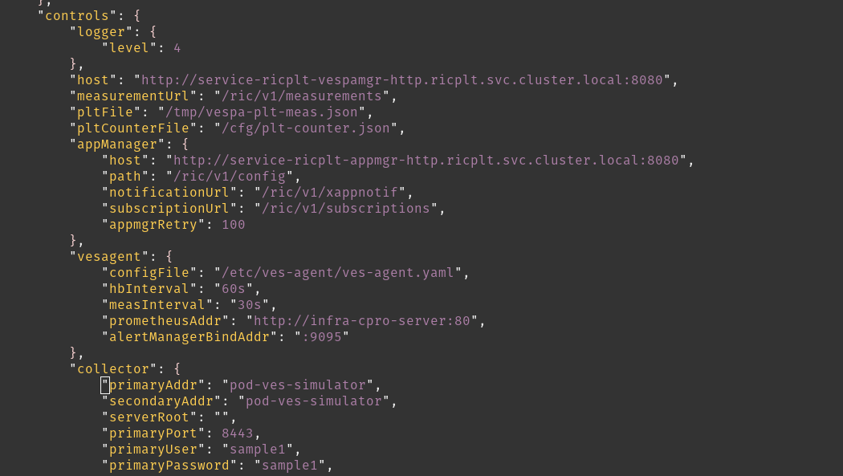

With - "prometheusAddr": "http://r4-infrastructure-prometheus-server.ricplt:80",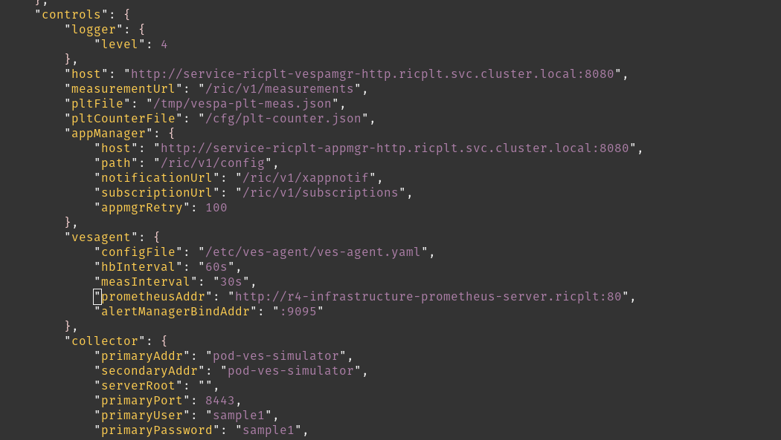

Replace-  
 "collector": {

"primaryAddr": "pod-ves-simulator",

"secondaryAddr": "pod-ves-simulator",

"serverRoot": "",

"primaryPort": 8443,

"primaryUser": "sample1",

"primaryPassword": "sample1",

"secure": false

}

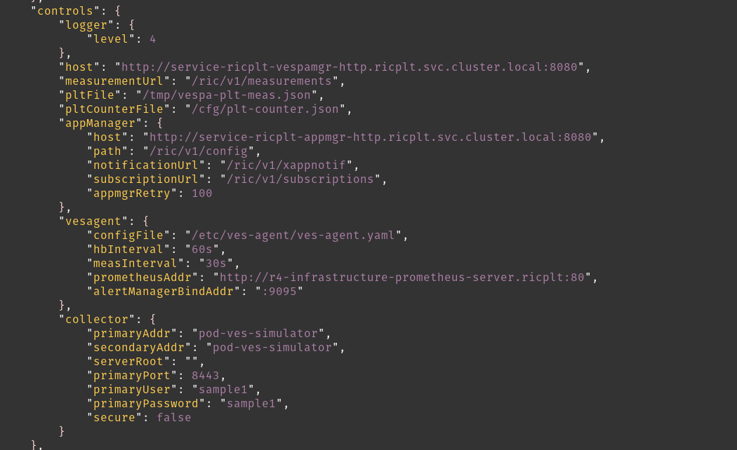  
With -

"collector": {

"primaryAddr": "192.168.122.233",<--------------------YOUR MACHINE IP ADDRESS

"secondaryAddr": "192.168.122.233",<--------------------YOUR MACHINE IP ADDRESS

"serverRoot": "",

"primaryPort": 9999,<---------------------------------Changed

"primaryUser": "user",<---------------------------------Changed

"primaryPassword": "password",<---------------------------------Changed

"secure": false

}

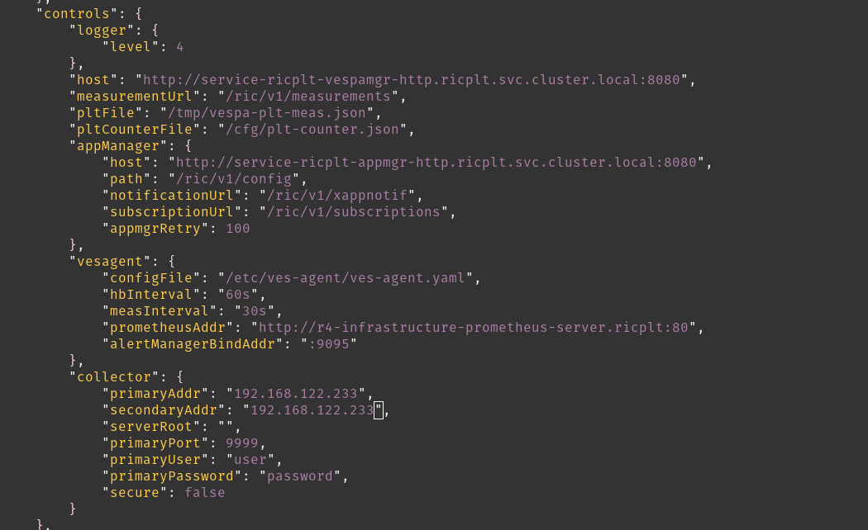

**Build custom image and push to local repository**

cd vespamgr/

sudo apt-get update && apt-get install -y apt-utils

docker build -t ric-plt-vespamgr:0.7.5 $PWD

docker push localhost:5000/ric-plt-vespamgr:0.7.5 <-------YOU MAY GET ERROR AS SHOWN BELOW



**To Resolve you may TRY**

docker run -d -p 5000:5000 --name registry registry:2



docker tag ric-plt-vespamgr:0.7.5 localhost:5000/ric-plt-vespamgr:0.7.5

docker push localhost:5000/ric-plt-vespamgr:0.7.5

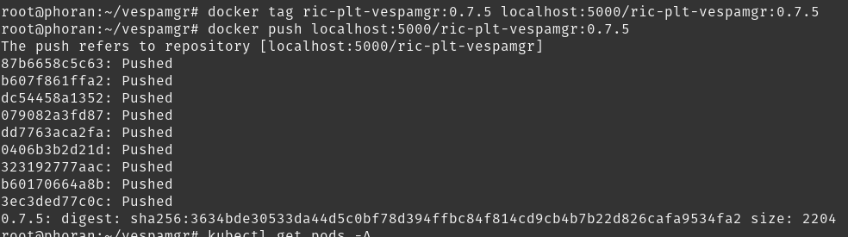

cd /

git clone https://github.com/openaicellular/oaic.git

cd ~/oaic/RIC-Deployment/tools/k8s/bin

./gen-cloud-init.sh

sudo ./k8s-1node-cloud-init-k_1_16-h_2_17-d_cur.sh

sudo kubectl get pods -A

sudo kubectl get ns ricinfra<-------------------(To check if ricinfa is already present or not if not create using bellow cmd)

sudo kubectl create ns ricinfra

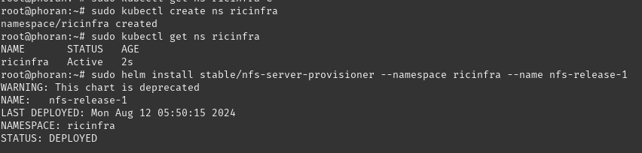

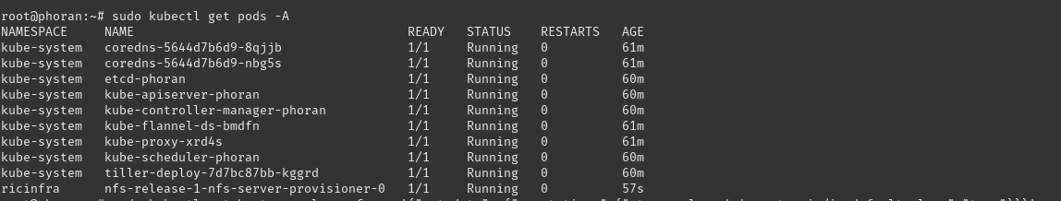

sudo helm install stable/nfs-server-provisioner --namespace ricinfra --name nfs-release-1

sudo kubectl patch storageclass nfs -p '{"metadata": {"annotations":{"storageclass.kubernetes.io/is-default-class":"true"}}}'

sudo apt install nfs-common



### **Build Modified E2 docker Image**

sudo docker run -d -p 5001:5000 --restart=always --name ric registry:2



cd /root/oaic/RIC-Deployment/bin



cp ../RECIPE_EXAMPLE/PLATFORM/example_recipe_oran_e_release_modified_e2.yaml \

../RECIPE_EXAMPLE/PLATFORM/example_recipe_oran_e_release_modified_e2_vespa.yaml

**Edit configs to pull from local repository**

vim ../RECIPE_EXAMPLE/PLATFORM/example_recipe_oran_e_release_modified_e2_vespa.yaml

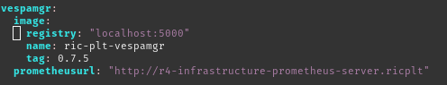

**Edit configmaps to match username and password and port as done for vespamgr above**

vim ../ric-dep/helm/vespamgr/templates/vespa-config.yaml

### 

### 

### **Deploy the near-Real Time RIC**

cd ~/oaic/RIC-Deployment/bin

sudo ./deploy-ric-platform -f ../RECIPE_EXAMPLE/PLATFORM/example_recipe_oran_e_release_modified_e2_vespa.yaml



kubectl get pods -A